**REST - Country Web Service - SME**

**1. What Happens in the Controller Method?**

* When the `/country` endpoint is hit:
* Spring executes `getCountryIndia()` method.
* It creates an ApplicationContext from `country.xml`.
* Retrieves the bean with id "country" of class Country.
* Returns it as the response.
* Spring automatically converts the returned object to JSON using Jackson.
* Response is sent with appropriate HTTP headers (`Content-Type: application/json`).

**2. How the bean is converted into JSON reponse?**

* Spring Boot uses Jackson (auto-configured)
* @RestController auto-converts return object to JSON
* Sets HTTP response header: Content-Type: application/json

**3. In network tab the HTTP header details received**

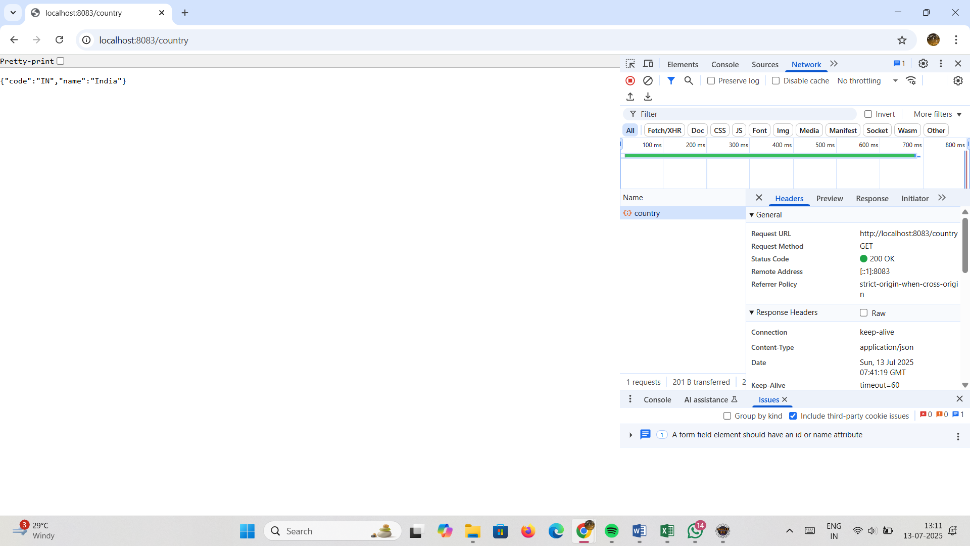

**4. In postman the HTTP header details received**

